3-D Checkers
User’s Guide

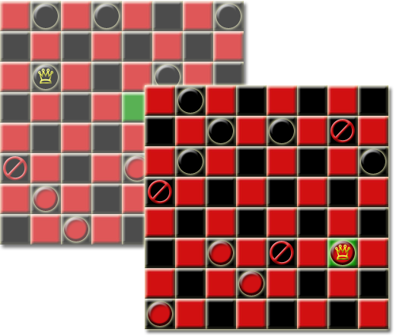

Team B
Benjamin McDowd, Byron Lunt, David Clark and Michael Sawtelle

Table of Contents
Introduction 4
Warranty Disclaimer 4
Installation 4
How to Play 4
How to Begin a Game 4
Manual Board Setup 7
Random Board Setup 8
Movement Rules 8
3-D Warp Moves 9
Terms 9
Instant Replay 10
Ending a Game 12
Request Draw or Forfeit 12
Save/Load Game 12
Saving a Game 12
Loading a Saved Game 13
Statistics 15
Administration 16

Table of Figures
Figure 1. Welcome Screen – New Game 6
Figure 2. Log In Screen 6
Figure 3. Board Size Screen 7
Figure 4. Coin Toss Screen 7
Figure 5. Manual/Random Setup Screen 7
Figure 6. Board Setup Screen 8
Figure 7. Play Game Screen 9
Figure 8. Select Instant Replay 12
Figure 9. Instant Replay Moves 12
Figure 10. Exit Instant Replay 12
Figure 11. Options Menu 13
Figure 12. Save Game 14
Figure 13. Welcome Screen - Load Game 14
Figure 14. Load Game Screen 15
Figure 15. Load Game – Login 15
Figure 16. Welcome Screen - Statistics 16
Figure 17. Enter Password - Statistics 16
Figure 18. Statistics Screen 17
Figure 19. Welcome Screen – Administration 18
Figure 20. Create New Administrator 18
Figure 21. Administrator Login 19
Figure 22. Adminstrator Options 19
Figure 23. Deleting a player 20
Figure 24. Changing Statistics 20
Figure 25. Clearing Player Statistics 21
Figure 26. Retiring an Administrator 21

Introduction
Welcome to 3-D Checkers, an exciting twist on traditional checkers that takes gameplay to another dimension!

Warranty Disclaimer
Team B makes no warranties, either expressly or implied, regarding the software described in this manual. In no event shall Team B be liable to anyone for incidental or consequential damages in connection with or arising from the use of this program. Team B shall not be liable for any claim against the user of this program by any other party.

Installation
To install the game, simply unzip the folder entitled “3D Checkers” and copy the entire folder to the desired directory. Then, open the folder and double-click the file named ‘3DCheckers.JAR’ and let the fun begin! All files and folders created throughout gameplay will be automatically placed within this folder.

How to Play

How to Begin a Game
- To begin a game, select “New Game” and click “Next” (see Figure 1).

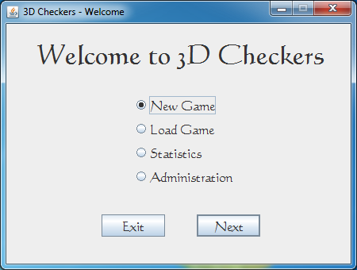
Figure 1. Welcome Screen – New Game
- Both players will log in by selecting their user names in the drop-down box and entering their passwords. If a player has not created a user name, select the “New User” button to create a user name and password. Once signed in, select the “Play Game!” button (see Figure 2).
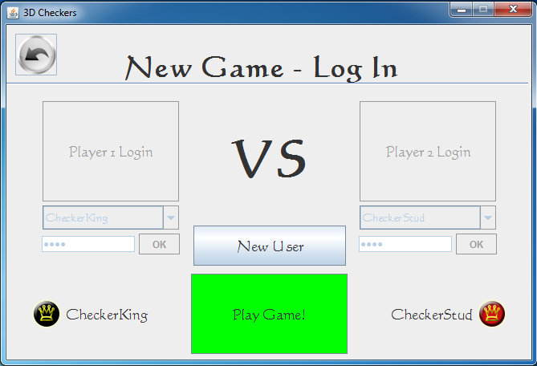
Figure 2. Log In Screen
- Select the board size (see Figure 3).
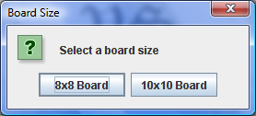
Figure 3. Board Size Screen
- Follow the coin toss prompts to determine the Home and Visitor players (see Figure 4)
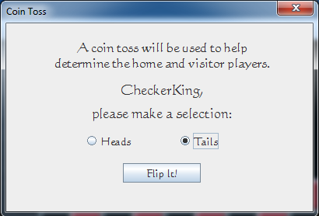
Figure 4. Coin Toss Screen
- Select the method of setting up the board (see Figure 5).
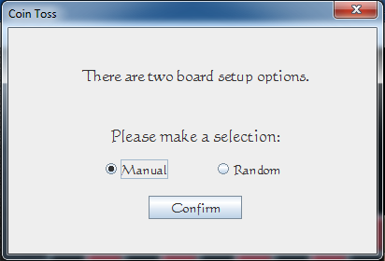
Figure 5. Manual/Random Setup Screen

Manual Board Setup
- The visitor player will begin placement by selecting a piece to be placed on the board.
- Then, select the location on the board to place the piece (see Figure 6).
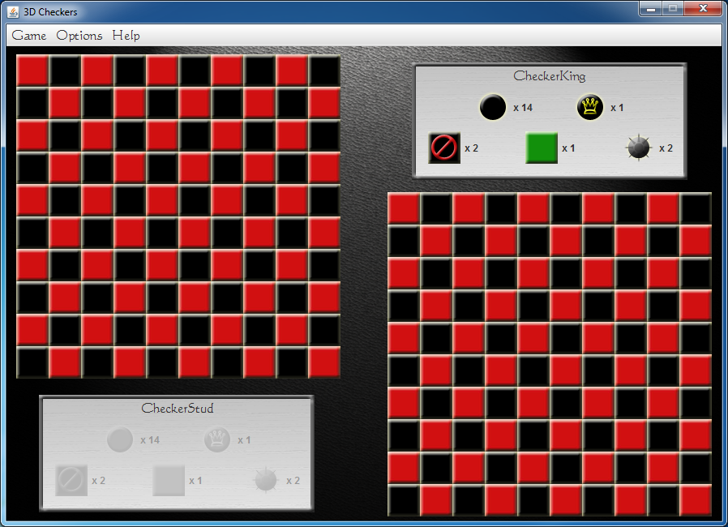
Figure 6. Board Setup Screen
- If the location is valid, the piece will take its position on the board. If the location is invalid, the player will need to restart at step 1 (see Table 1 for valid piece placement).
- The home player will repeat steps 1 through 3.
- Players will alternate turns until all pieces have been placed.
Piece | Valid Rows
Checker | Own 1 through 3
King | Own 1 through 3
Blocked Square | Own half of board
Safe Zone | Own half of board
Smart Mine | Own half of board
Table 1. Valid Piece Placement
- Once all pieces have been placed, the game will begin (see Figure 7).

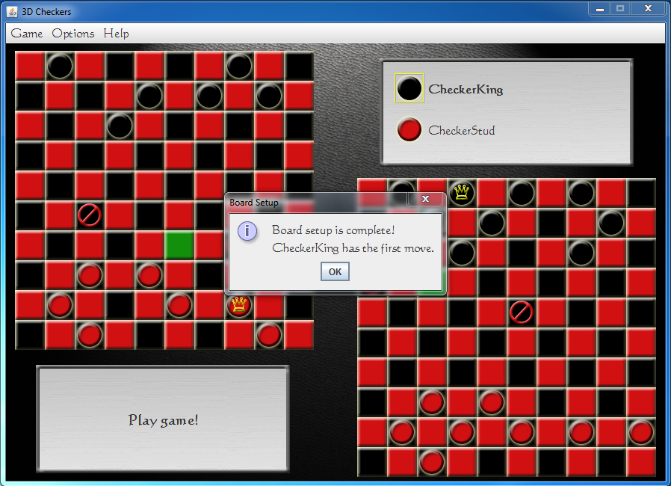
Figure 7. Play Game Screen
- The visitor player has the first move.

Random Board Setup
Random board setup will randomly place all pieces on the board. This option should be used for starting a game quickly or to eliminate the strategy of manual piece placement.

Movement Rules
Checkers 3-D works similar to traditional checkers; however, there are a few differences. The following is a list of possible moves in 3-D Checkers:
- Players alternate turns during game play.
- Only one piece may be moved during each turn.
- Moves are only allowed on black squares, therefore the pieces always move diagonally.
- Movement for normal checkers (non-King):
  - May only move forward (toward the opponent).
  - May only move one square for non-capturing move (not involving a jump).
  - May capture an opponent’s piece, by performing a diagonal jump over the piece. Only one piece may be taken with a single jump; however, multiple jumps may be performed on a single turn.
  - May perform a warp to the other board. (see 3-D warp moves for additional information)
- Movement for Kings:
  - May perform any move that a normal piece can make.
  - May move in either direction.
  - May perform a both a “warp” and a normal move on a single turn. (see 3-D warp moves for additional information)
- A checker that lands on the back row of his/her opponent will be converted to a King. The player’s turn ends when this occurs.
- Once a piece is captured, it is removed from the board.
- A piece may not be captured if it is located on a Safe Zone (see Safe Zone for additional information).
- A piece that lands on an opponent’s Smart Mine is removed from the board (see Smart Mine for additional information).
- A piece may not be moved onto Blocked Squares (see Blocked Square for additional information).
- If a jump is available to a player, the jump must be taken; however, when performing a sequence of multiple jumps, a player may choose whether or not to continue after the first jump.
- If, after performing a jump, additional jumps are available, the board will highlight the location of the next jump. If the player does not wish to take the jump, he/she may click on any square other than the highlighted square to end his/her turn.

3-D Warp Moves
- A player may warp from one board to the other.
- The piece being warped is transported to the same square on the other board. If the corresponding square on the other board is currently occupied, a warp is not allowed.
- Only one warp is allowed per move (including multiple jumps).

Terms
Checker: A standard game piece. Checkers can move diagonally forward, or warp to the other board. Moving a checker using a warp move ends the player’s turn. A checker can be converted to a King by landing on the back row of his/her opponent.
King: An upgraded game piece. A King can move both diagonally forward or diagonally backward. A King may move, and then warp - or - warp, and then move during a single turn.
 Blocked Square: Each player must designate two Blocked Squares on his/her half of the board(s) during game setup. Blocked Squares are visible to both players. No piece may move into a Blocked Square.
 Safe Zone: Each player must designate one square on his/her half of the board(s) as a safe zone during game setup. Safe Zones are visible to both players. Either player’s piece is safe while in the Safe Zone and cannot be captured by enemy pieces.
Smart Mine: Each player must place two smart mines on his/her half of the board(s) during game setup. Smart Mines are hidden during game play. A smart mine will capture any enemy piece that lands on it, but is harmless to a player’s own pieces. Once detonated, Smart Mines are removed from the board.
Coin Toss: Used to determine the home / visitor players. The visitor player places the first piece during setup, and takes the first turn.
Forfeit: Either player may elect to forfeit and end the game immediately instead of taking his/her next turn. When a player forfeits the game, it is counted as a loss.
Draw: Either player may ask his/her opponent to agree to a draw instead of taking his/her next turn. If both players agree to the draw, the game ends immediately.

Instant Replay
Players have the option of replaying moves that were made during a game.
- Select “Options” from the menu bar and then select “Instant Replay” (see Figure 8).
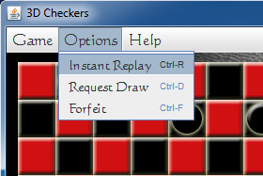
Figure 8. Select Instant Replay
- Use the navigation buttons to cycle through the moves. Or, alternately, enter the number of the desired move and press <ENTER> (see Figure 9).
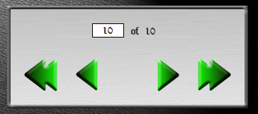
Figure 9. Instant Replay Moves

- Press “EXIT” at any time to resume the game (see Figure 10).

Figure 10. Exit Instant Replay

Ending a Game
There are three ways of ending a game:
- Forfeit
- Draw
- Capture all of the opponent’s pieces

Request Draw or Forfeit
- Select the “Options” menu and select “Request Draw” or “Forfeit” (see Figure 11).
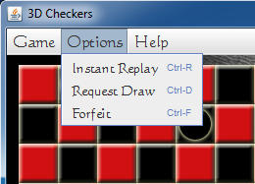
Figure 11. Options Menu
- To request a draw:
  - Both players must enter their passwords.
  - The game will be counted as a tie for both players.
- To forfeit:
  - It must be your turn.
  - You must enter your password to authorize the forfeit.
  - The game will be counted as a loss for the forfeiting player and a win for his/her opponent.

Save/Load Game

Saving a Game
- To save a game, click on “Game” in the menu bar and then “Save Game” (see Figure 12).
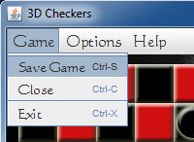
Figure 12. Save Game
- The game will be saved with the player names and date for future recovery.

Loading a Saved Game
- To load a saved game, select “Load Game” and then click “Next” on the Welcome Menu (see Figure 13).
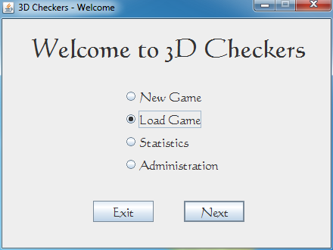
Figure 13. Welcome Screen - Load Game
- You will be provided a list of saved games. Select the game you would like to continue playing and click “Open” (see Figure 14).
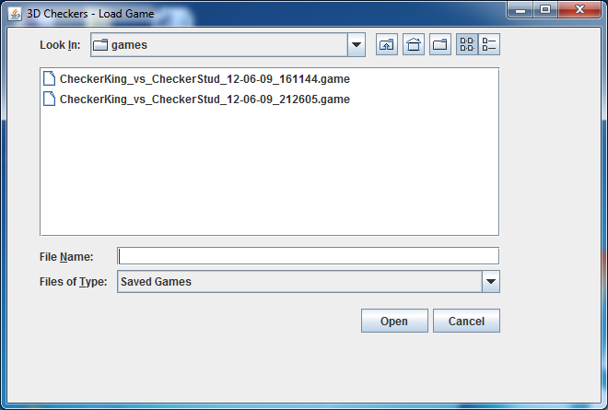
Figure 14. Load Game Screen
- Both players will be required to login before the game will load (see Figure 15).
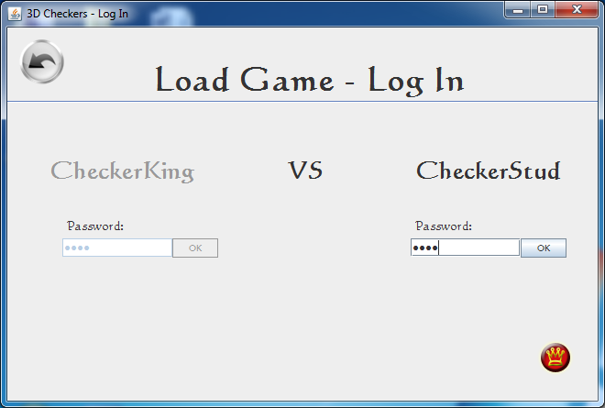
Figure 15. Load Game – Login

Statistics
During the course of gameplay, the game will automatically keep track of each player’s statistics. These statistics include:
- Wins
- Losses
- Ties
To access statistics:
- From the Welcome Screen, select “Statistics” and click “Next” (see Figure 16).
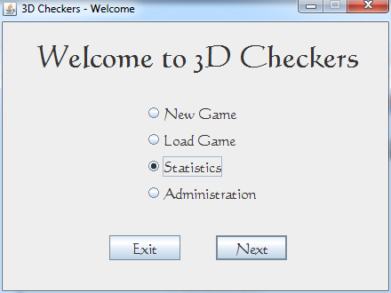
Figure 16. Welcome Screen - Statistics
- The player will then enter his/her password and select “OK” (see Figure 17).
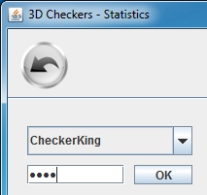
Figure 17. Enter Password - Statistics
- The player’s statistics will then populate (see Figure 18).
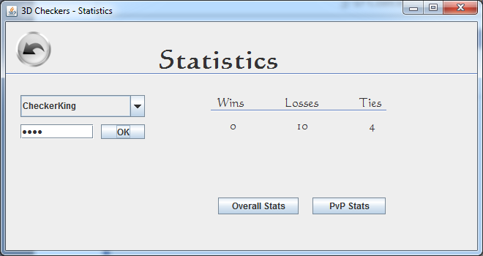
Figure 18. Statistics Screen
- Select the “PvP Stats” button to view head-to-head statistics against another player.

Administration
Only players with authorization (password) can access this menu option. Within this menu, the administrator can delete all player statistics so that new statistics will be kept. The administrator also has the capability to delete specific players and their statistics. This facilitates league play, if someone violates the regulations, they can be removed from the tournament by the administrator.
To access the statistics menu:
- From the Welcome Screen, select “Administration” and click “Next” (see Figure 19).
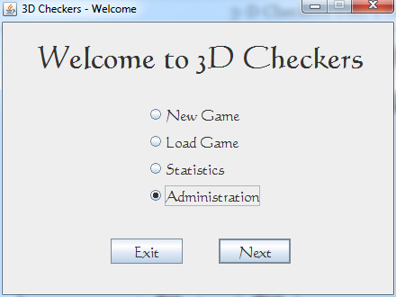
Figure 19. Welcome Screen – Administration
- If an administrator has not been created yet, then the first time this menu item is selected, the user will be prompted to create an administrator login and password (see figure 20)

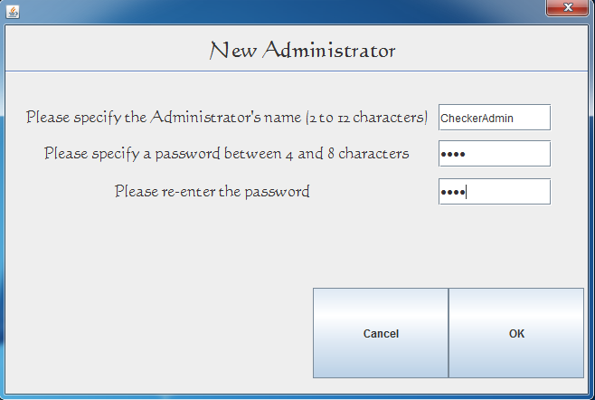
Figure 20. Create New Administrator
- The administrator will then enter his/her password and select “OK” (see Figure 21).
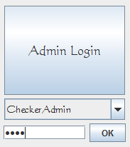
Figure 21. Administrator Login
- After the administrator logs in, the following options will be displayed: Delete Player, Change Stats, and Clear Stats. (see Figure 22)
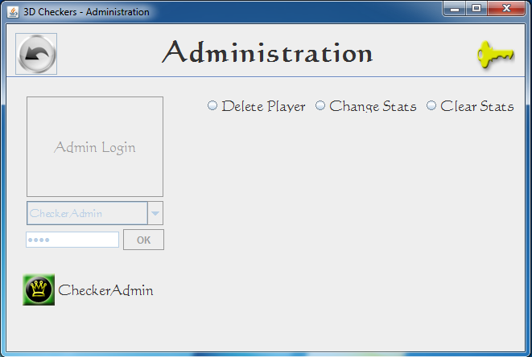

Figure 22. Adminstrator Options
- Upon selecting ‘Delete Player’ the administrator is prompted to select the player to
delete and then prompted for his/her administrator password press OK and the selected player is deleted (see Figure 23).

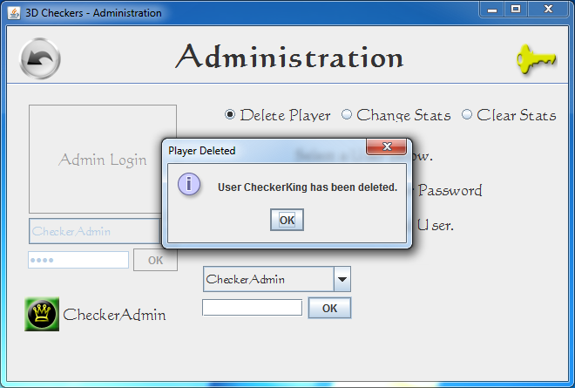
Figure 23. Deleting a player
- Upon selecting ‘Change Stats’ two selection boxes appear, from the top one the administrator selects the user for whom the stats are to be changed, the second selection box is for changing stats for PvP, there are buttons with ‘+’ and ‘-‘ on them to increase or decrease each individual stat (see Figure 24).

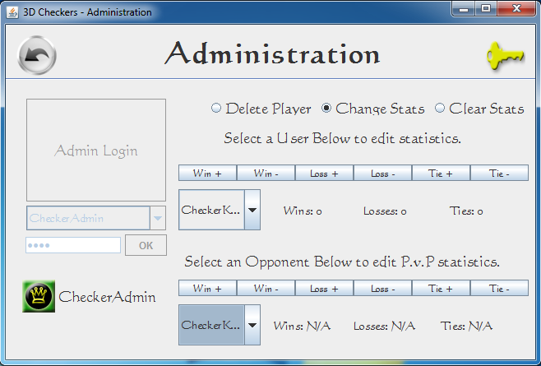
Figure 24. Changing Statistics
- Upon selecting ‘Clear Stats’ the administrator is prompted for his/her password, after entering the password the administrator then can press OK , then all the stats will be cleared (see Figure 25).

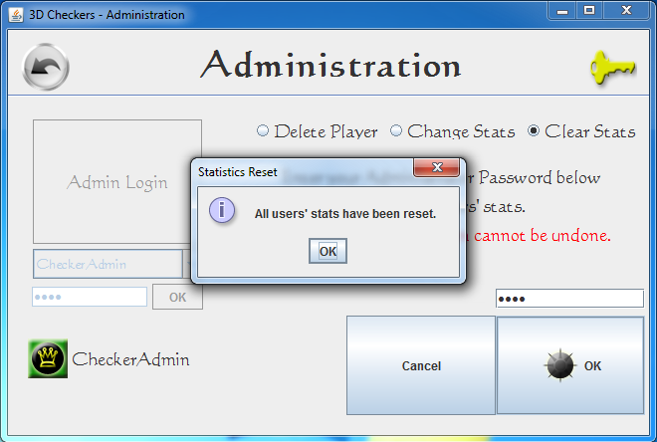
Figure 25. Clearing Player Statistics
- Another option in the administrator screen is the golden key in the upper right corner. This option is there so that the administrator can retire and another can login the next time the Administrator menu is accessed (see Figure 26).

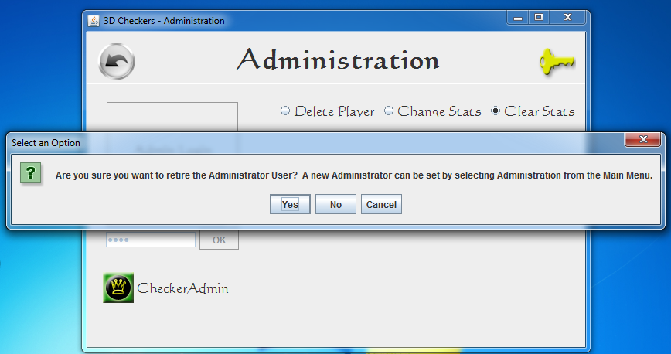
Figure 26. Retiring an Administrator

